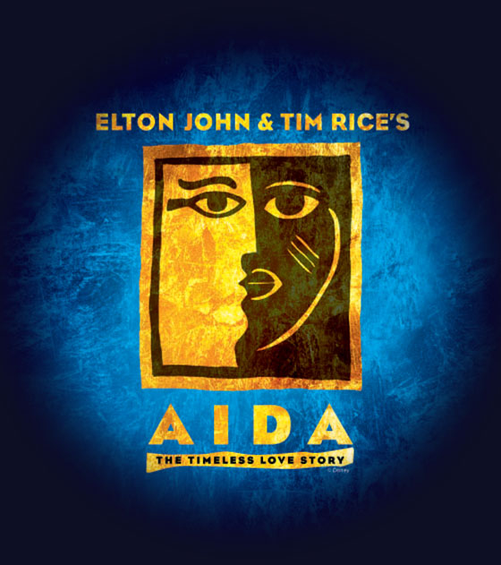

**WHEN: Saturday Dec. 7th from 7pm to 11pm**

**WHERE**: The Spicuzza Home (651-436-3339)

11456 Middleton Trail, Woodbury, 55129

**SOUPS AND BREAD WILL BE SERVED**

**WHAT STUDENTS SHOULD BRING**:

A-E: 12-pack diet soda—preferably cold

F-J: 12-pack regular soda—preferably cold

K-P: Dessert

Q-T: Appetizer

U-Z: 12-pack (or thereabouts) bottled water—preferably cold

See you there!

Aida cast/Crew/

Orchestra/staff party!